BASIC SCIENCES PROMOTION
REGULATIONS - APPENDIX 10
[Approved by Policy Board Dec 9, 2025]

PROMOTION PROCEDURES

The promotion procedure will be as noted in Regulations 21 (e).
The promotion criteria and the marking are only for the Medical College or Institutional promotion committee (IPC). Promotion is based on these criteria and no interview is required.

The departmental promotion committee should be aware of these criteria when preparing the dossier and nominating a faculty member for promotion. The departmental nomination must be accompanied by a supporting letter from the chairman outlining the rationale for the nomination indicating the track, regular or clinical, and addressing each of the
requirements for the chosen track. The letter should also affirm that it represents the departmental committee consensus.

BASIC SCIENCES - CRITERIA FOR PROMOTION
TO ASSOCIATE PROFESSOR/ PROFESSOR
a. Certified supervisor of Ph.D students (minimum of 3 students under current or previous supervision) OR certified supervisor of FCPS (basic sciences) trainees (minimum of 3 trainees under current supervision).
b. For promotion to Associate Professor a minimum of 5 years as assistant professor is required. Promotion in the 5th or 6th year in the post will be considered accelerated promotion (see below). In all cases the promotion process must start in the 7th year to be completed by the end of the eighth year in the post.
For promotion to Professor a minimum of 5 years as associate professor is required. Promotion in the 5th or 6th year in the post will be considered accelerated promotion (see below). In all cases the promotion process must start in the 7th year to be completed by the
end of the eighth year in the post.
c. EXCEPT IN THE CASE OF ACCELERATED PROMOTION FOR OUTSTANDING MERIT (Scores 70% or more) when appointment may occur after a minimum of 5 years as assistant professor or associate professor for promotion to associate or full professor respectively, and the candidate must meet all requirements for regular promotion and also
have:
i) At least 8 first or corresponding author papers in the post IN ADDITION TO whatever paper requirement existed for the previous post.
ii) Evidence of outstanding teaching performance – documented by letters from peers, with specifics (i.e., it isn’t adequate to say “he’s a great teacher”
– specific instances must be documented). Supervisor for more than 5 Ph.D students or FCPS (basic science) trainees, current or already graduated.
iii) Recognition as an excellent teacher, properly documented.
iv) CME activities (At least 10 conferences/workshops during the current post).
v) Member of an academic or administrative committee of an institution.

SCORING TABLE for IPC for BASIC SCIENCES PROMOTION:

Name:
Promotion Track:
Mode of Promotion: Regular/Accelerated
Promotion To:
Minimum PMDC Criteria (Teaching Regulations 2025)
- Qualification, Experience & Publications
- CHPE Certificate
- PMDC Valid Registration
- PMDC Faculty Registration
- PMDC Experience Certificate
Note: Evidence of having applied for PMDC Registration/Certification must be attached and the final document must be submitted before final notification.
S.  no | Item |  | Max  marks | DPC Marks | DPC justification and Remarks | IPC Marks |  | IPC Remarks
1 | a. ACHIEVEMENT IN EDUCATION¹  The development of one of the following and objective  demonstration of its positive outcomes. There must be objective evidence of the candidate’s personal contributions to the development or improvement.  a. New and/or innovative educational program  b. New and/or innovative curriculum  c. Leadership of new and/or innovative educational programs  d. New and/or innovative assessment tools  e. A recognized leader in the skills of mentoring/advising  b. Ph.D SUPERVISOR (5 marks for each Ph.D student in  addition to required 3 Ph.D students) OR FCPS (basic  sciences) SUPERVISOR (5 marks for each FCPS  trainee in addition to required 3 FCPS trainees)  Appendix 1: Policy Board Letter 1  Appendix 2: Policy Board Letter 2 |  | 25  15
2 | Excellent teacher²  Defined as having the following qualities:  i) A minimum of 05 presentations per year in the current post on clinical and educational topics verified by different means (CPCs, Multidisciplinary meetings, workshops, conferences, CMEs) (max 10 marks)  ii) Written evaluations from trainees and students (max 10 marks)  *Evidence in the form of Title of presentation, abstract booklet, schedule of conference, minutes and certificates etc be presented. |  | 15
3 | CME Credit hours [0.1 mark / credit hour] |  | 5
4 | Scholarly  activities | Presentations at National or International  Conferences (with paper/ abstract  presentation) (1 mark for each),  Workshop/symposia organiser (1 mark for each)  Editor of Nationally recognized Journal (2 marks for each) | 15
4 | Scholarly  activities | a) Review article, meta-analysis, editorial in recognized journal over and above mandatory 3 articles, 0.5 marks each  b) Reviewer of journal article 0.5 marks each | 15
5 | Administrative activities³  Member (4 marks)/ chairman (6 marks) of different Hospital or Academic administrative committees (including inquiry committees)  *Notification by competent authority i.e Dean, MD, HD, Directors must be attached. |  | 15
6 | Personal qualities and reputation⁴  i. No legal cases relevant to faculty duties with adverse outcomes to the applicant  ii. Good interpersonal relations with peers, students, trainees  iii. No adverse comments/reprimands in file (a minimum of 1 mark will be deducted for each adverse comment/reprimand in file) |  | 10

Zero marks in any category will disqualify the candidate for promotion.

For promotion to Professor in the Basic Sciences, achievement in education and research must be new and in addition to that on the basis of which the individual was promoted to associate professor.

N.B.
1.ALL MEMBERS OF THE INSTITUTIONAL PROMOTION COMMITTEE (IPC) ARE REQUIRED TO WRITE THEIR RATIONALE FOR AWARDING MARKS FOR EACH ITEM
1. IF THE MARKS GIVEN BY ANY MEMBER OF THE INSTITUTIONAL PROMOTION COMMITTEE FOR ANY ITEM FALL OUTSIDE THE AVERAGE MARKS OF ALL THE MEMBERS FOR THAT ITEM BY MORE THAN 25%, THE REVIEWER MAY RECONSIDER HIS/HER MARKS, OR THE REVIEWER’S MARKS WILL BE EXCLUDED FROM THE FINAL CALCULATION.
2. IF THE CANDIDATE HAS WORKED IN ANOTHER REPUTABLE INSTITUTION AS A FACULTY MEMBER, THAT TIME SHOULD BE CONSIDERED, AS WELL THE PAPERS PUBLISHED DURING THAT POSTING.

Appendix 1: Policy Board Letter 1

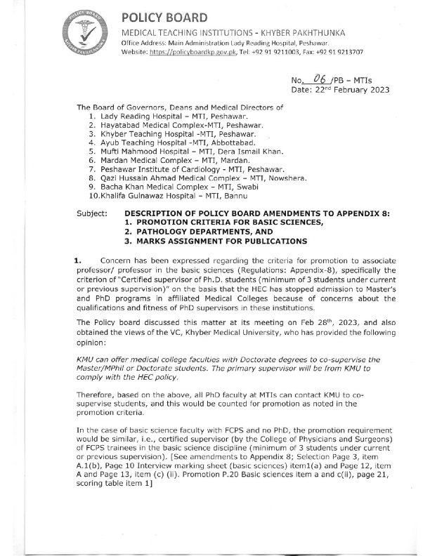
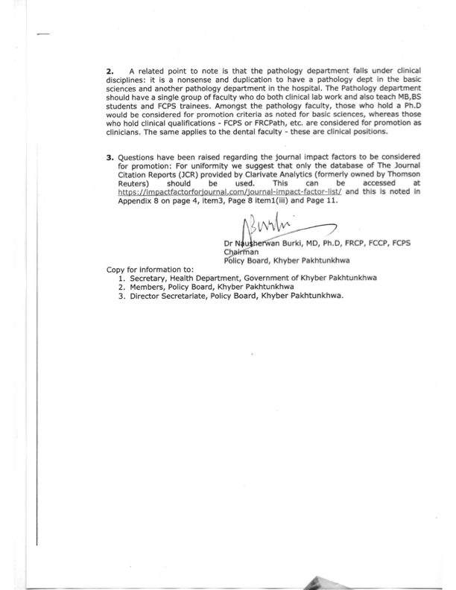
Appendix 2: Policy Board Letter 2
